California (CA)

Stepwise BIC Plot:
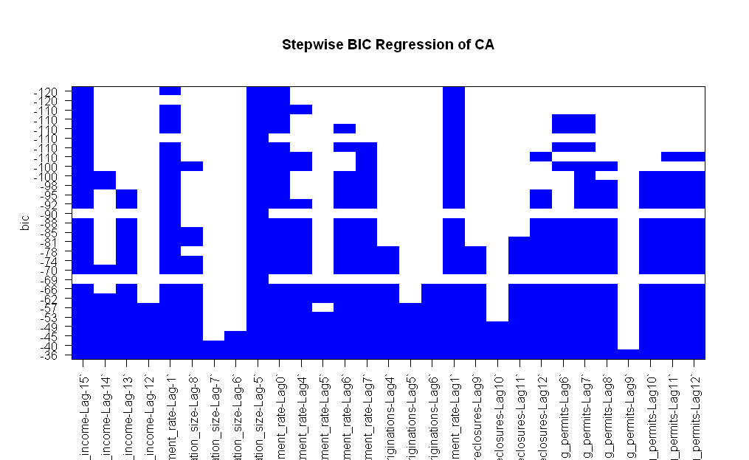

Fitted Model:

> y = rlm(shifted.multivar.test.data.vector[,1:(n-1)],shifted.multivar.test.data.vector[,n])
> summary(y)

Call: rlm(x = shifted.multivar.test.data.vector[, 1:(n - 1)], y = shifted.multivar.test.data.vector[,
n])
Residuals:
Min 1Q Median 3Q Max
-0.015833 -0.001059 0.001613 0.004622 0.023314

Coefficients:
Value Std. Error t value
median_income-Lag-15 0.4111 0.1164 3.5323
population_size-Lag-5 9.2055 0.6355 14.4846
unemployment_rate-Lag1 -0.1176 0.0368 -3.1952
foreclosures-Lag11 -0.0023 0.0008 -2.8118
foreclosures-Lag12 -0.0023 0.0008 -2.7886

Residual standard error: 0.004613 on 93 degrees of freedom

Stationarity Test
> adf.test(y$residuals)

Augmented Dickey-Fuller Test

data: y$residuals
Dickey-Fuller = -2.2136, Lag order = 4, p-value = 0.4882
alternative hypothesis: stationary

Plot
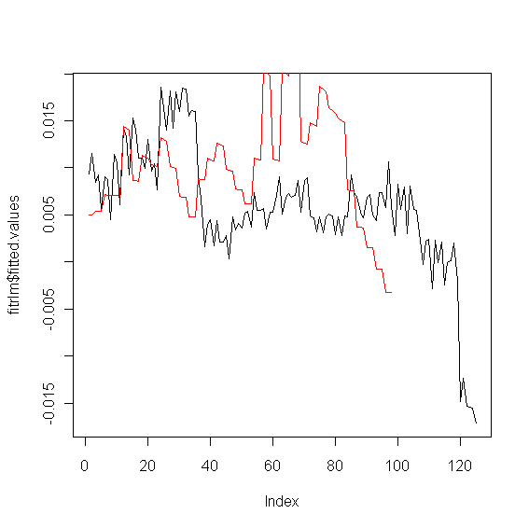
Black: fitted values
Red: Shifted lagged

